 Software Eng. Dep: Extension Addis Ababa Institute of Technology

**Computer Architecture**

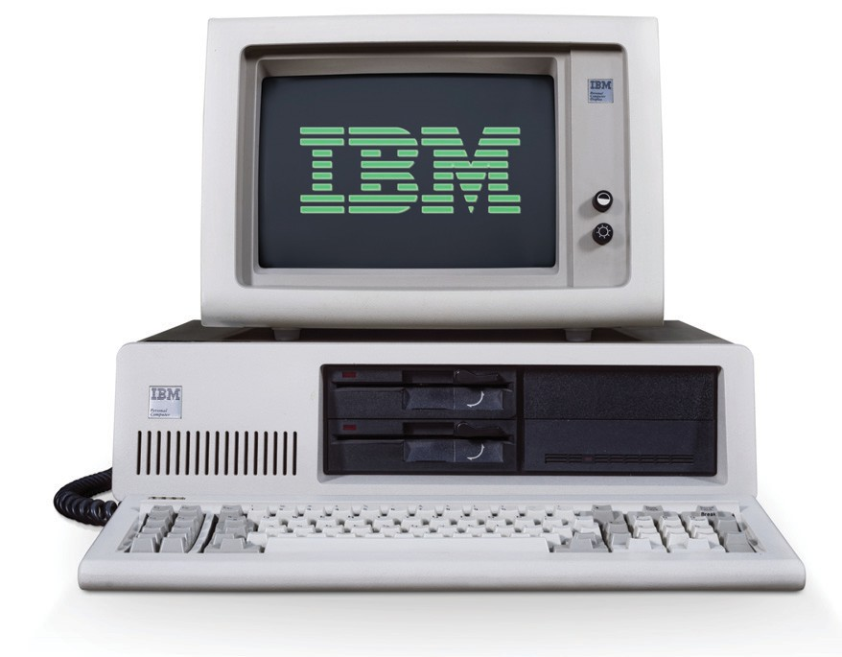

Amanuel Legesse

ATE/3628/1

IBm PC

5150 SUBMITTED TO: -

ABEBE A

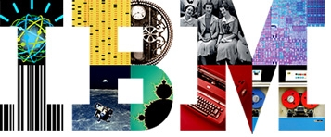

The IBM Personal Computer is the first microcomputer released in the IBM PC model line and the basis for the IBM PC compatible.

The IBM PC was the first commercially successful personal computer. It was introduced in August 1981 and quickly became the standard by which all other personal computers were judged. The IBM PC was powerful, reliable, easy to use and affordable for the average person. It was also the first computer that was 100% compatible with the original IBM PC/AT microprocessor.

* The IBM PC had a lot of features software and hardware wise some of the configurations are as follows:

|  |  |
| --- | --- |
| Model | IBM PC (5150) |
| History | Introduced: August 1981  Discontinued: April 1987 |
| CPU | Intel 8088 @ 4.77 MHz |
| RAM | IBM Monochrome Display Adapter or  IBM Color Graphics Adapter |
| Display | IBM 5151 monochrome display    IBM 5153 color display  Composite-input television |
| Input | IBM Model F 83-key keyboard with five-pin connector |
| Sound | Single programmable-frequency square wave with built-in speaker |
| Storage | Up to two 5.25", 160 kB/320 kB (single/double sided) floppy disk drives  Port for attaching to cassette tape recorder  Optional hard disk drive |
| Expansion | Five 62-pin expansion slots attached to 8-bit CPU I/O bus  IBM 5161 Expansion Chassis with eight (seven usable) extra I/O slots |
| Communications | Optional serial and parallel ports |
| Software | IBM PC DOS, CP/M-86, UCSD p-System |

* Reception of the IBM PC was extremely positive. Even before its release reviewers were impressed by the advertised specifications of the machine, and upon its release reviews praised virtually every aspect of its design both in comparison to contemporary machines making it one of the most memorable PC in computing history.